Project SCCS Risk Window Scanning
  - Descriptive Analysis
Trang Tu - Albert Chuang
Check the structure of imported files:
List of 7
$ individual :'data.frame': 7100 obs. of 15 variables:
$ myo_sccs :'data.frame': 1035 obs. of 19 variables:
$ pe_sccs :'data.frame': 3666 obs. of 19 variables:
$ thrc_sccs :'data.frame': 941 obs. of 19 variables:
$ covid_infection:'data.frame': 4704 obs. of 2 variables:
$ comorb_stat :'data.frame': 7100 obs. of 6 variables:
$ covid_vacc_wide:'data.frame': 2739 obs. of 5 variables:

Distributions of exposures and outcomes

Distribution of outcome events over the observation period:
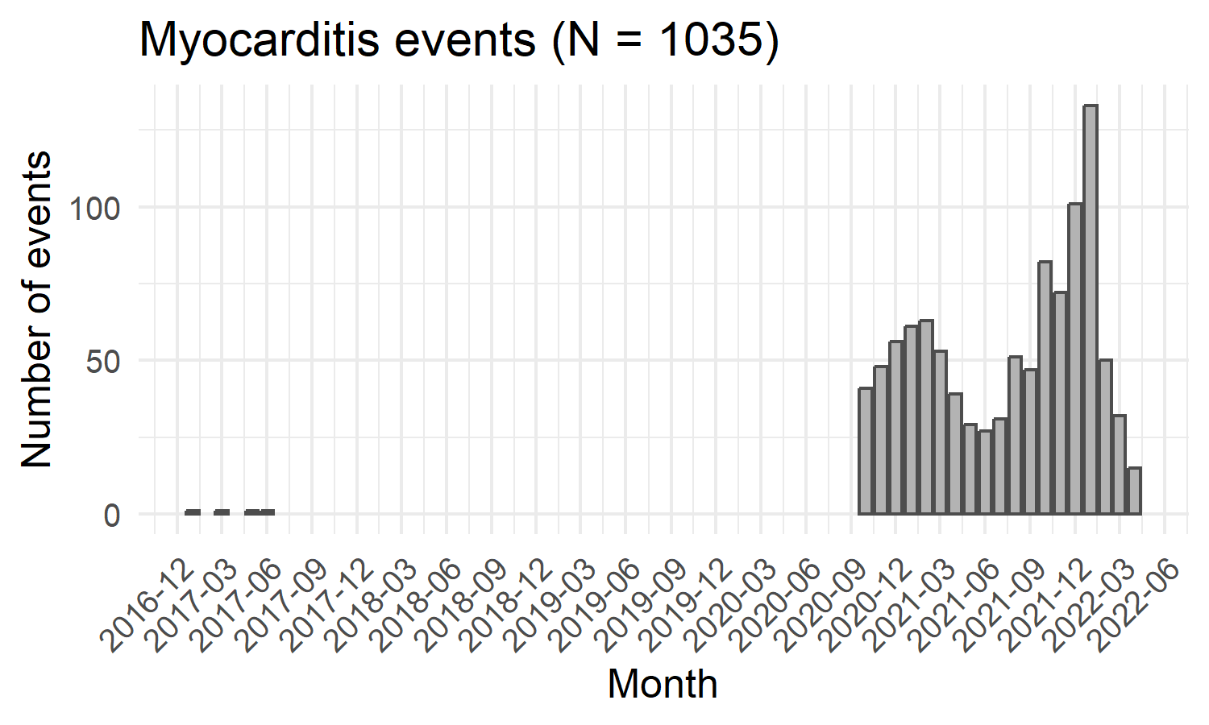
Figure 1: Monthly event counts by outcome
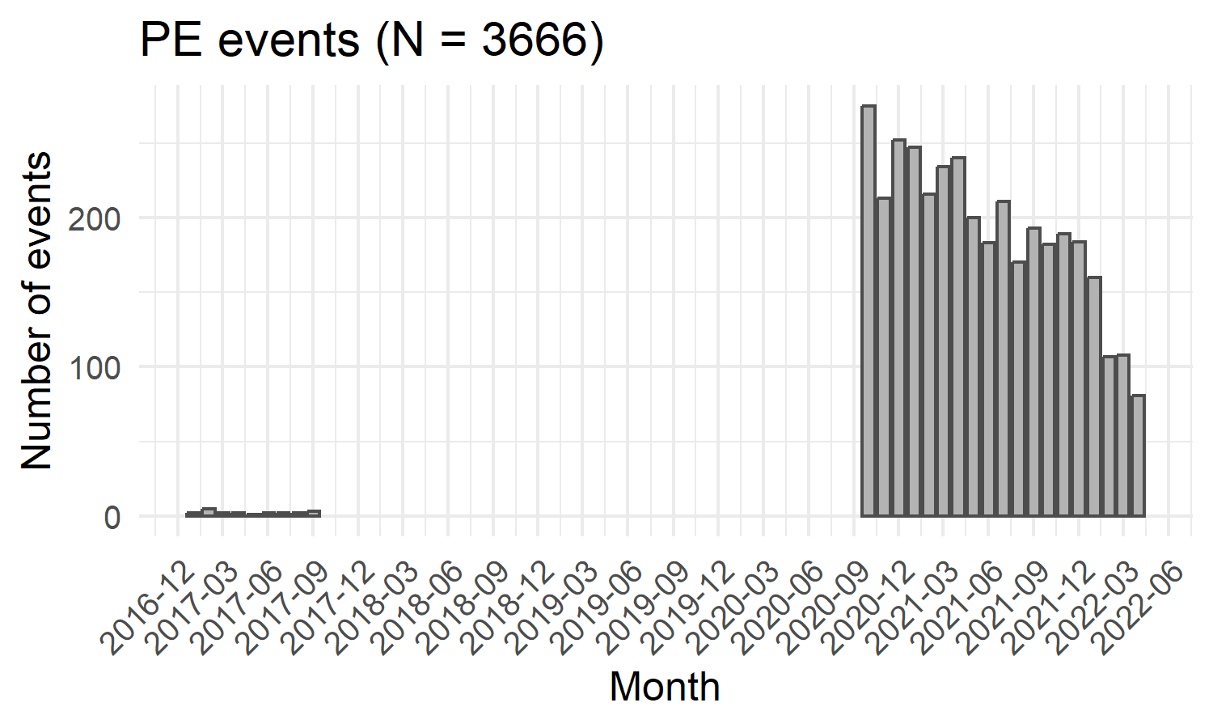
Figure 2: Monthly event counts by outcome
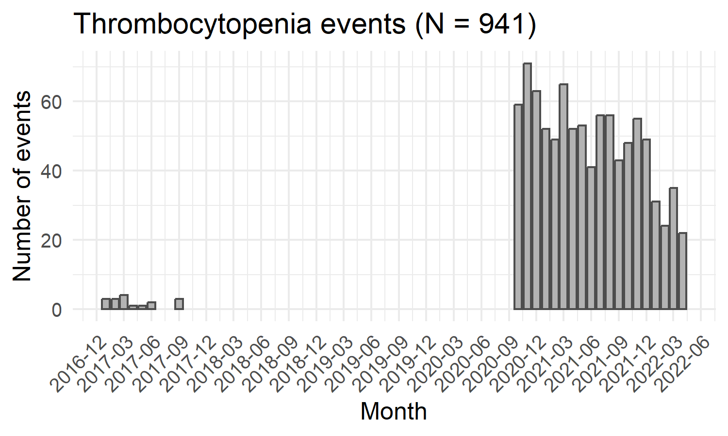
Figure 3: Monthly event counts by outcome

Distribution of vacc date
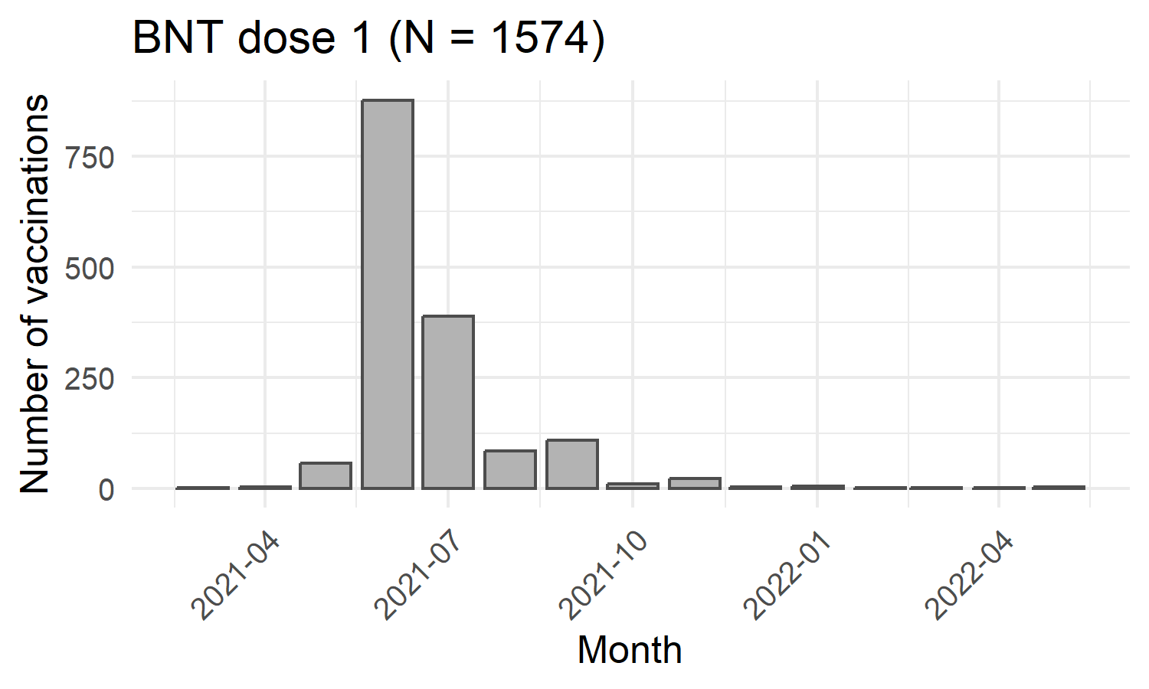
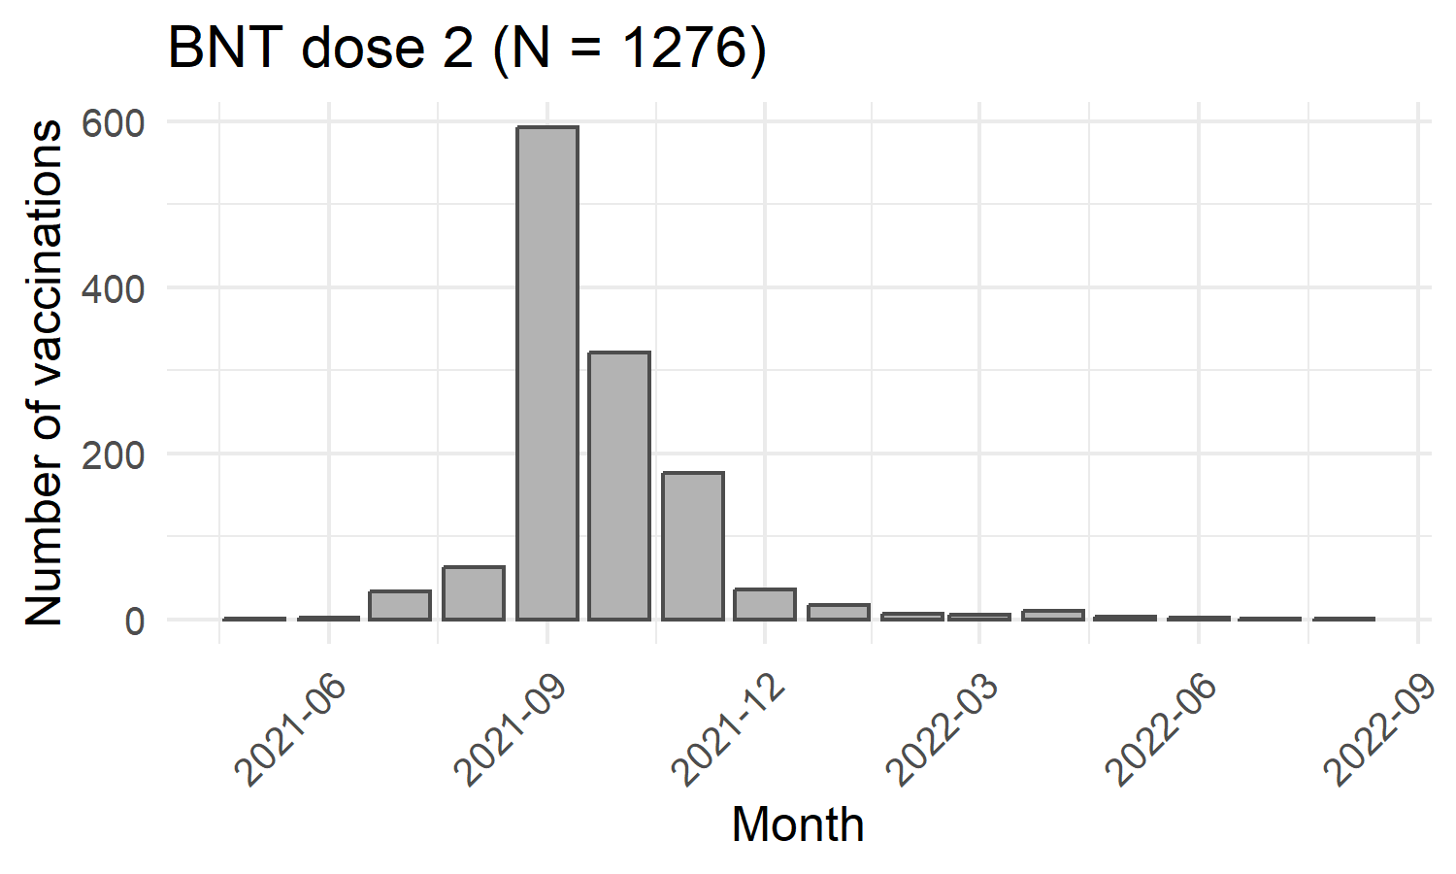
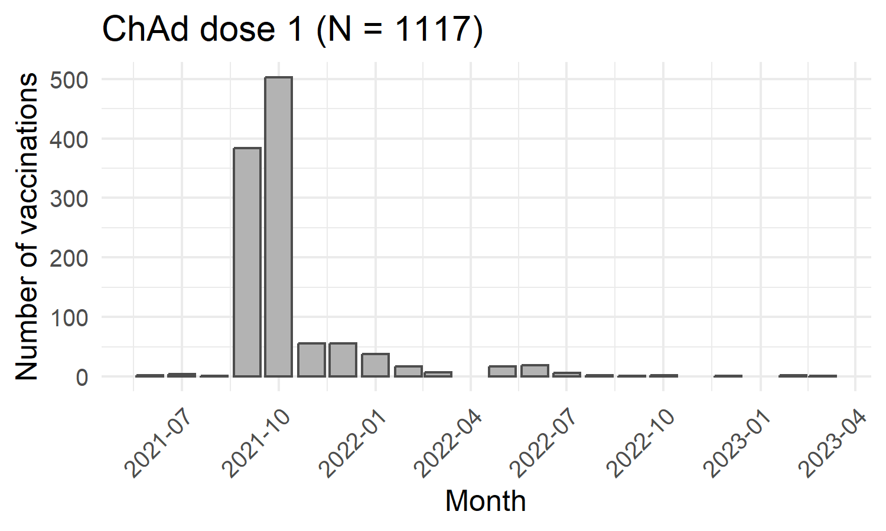
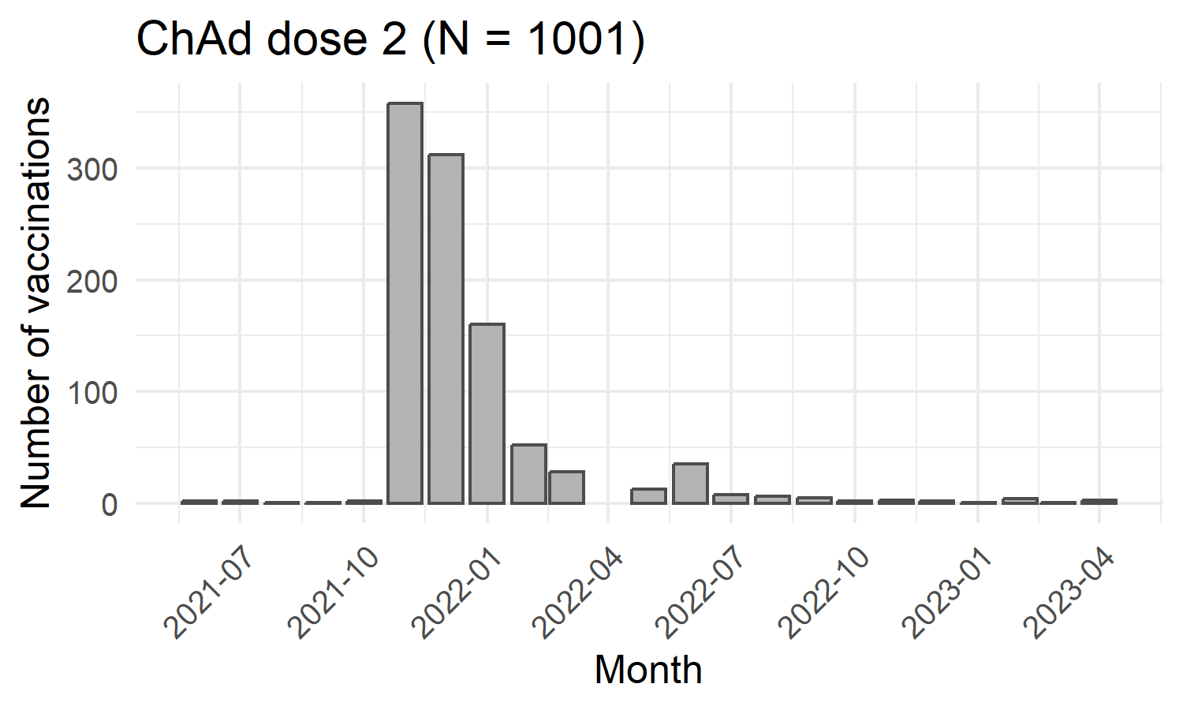

Dosing interval
- bnt_interval and chad_interval: interval between vaccine dose 1 and the earliest of (dose 2, end of observation).
- bnt2_to_end and chad2_to_end: interval between dose 2 and end of observation.
bnt_interval bnt2_to_end chad_interval chad2_to_end
Min. :-714.0 Min. :-771.0 Min. :-285.00 Min. :-549.00
1st Qu.: 83.0 1st Qu.: 105.0 1st Qu.: 37.00 1st Qu.: 85.00
Median : 92.0 Median : 127.0 Median : 44.00 Median : 110.00
Mean : 115.7 Mean : 141.1 Mean : 54.63 Mean : 89.01
3rd Qu.: 102.0 3rd Qu.: 187.0 3rd Qu.: 86.00 3rd Qu.: 134.00
Max. : 367.0 Max. : 282.0 Max. : 218.00 Max. : 308.00
NA's :1165 NA's :1463 NA's :1784 NA's :1738
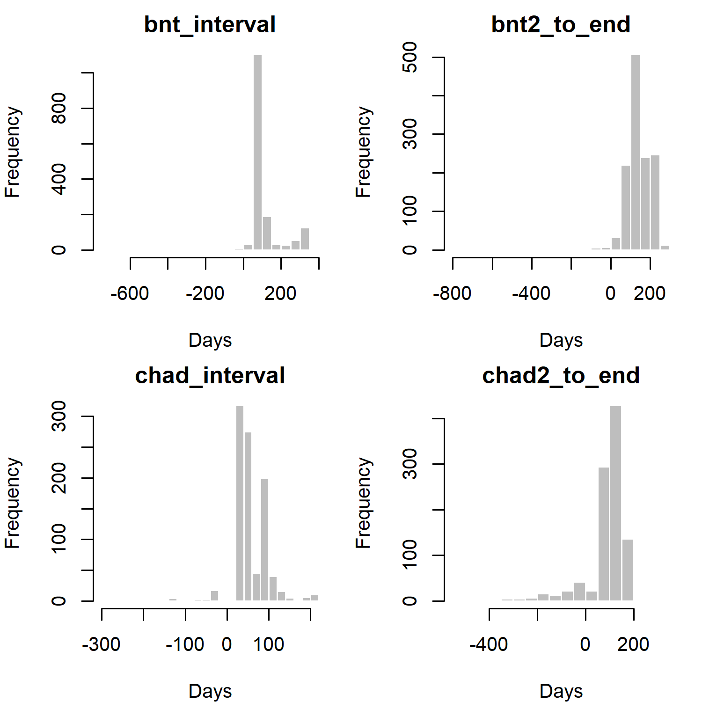
Figure 4: Interval in days between dose 1 and dose 2, and between dose 2 and end of observation

Distribution of 1st COVID-19 infection
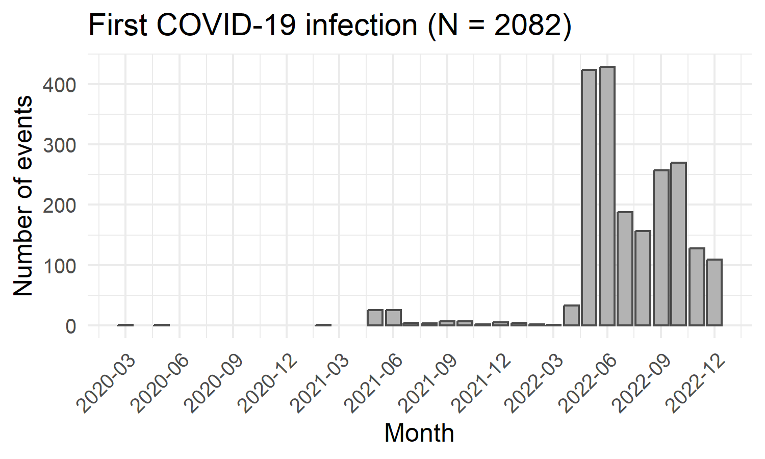
Figure 5: Monthly incidence of COVID-19 infection

Number of vaccinated cases (events could occur before or after vaccination)
Myocarditis (N cases = 1035 )
case_bnt1 case_bnt2 case_chad1 case_chad2
246 207 475 389
PE (N cases = 3666 )
case_bnt1 case_bnt2 case_chad1 case_chad2
851 647 368 343
Thrombocytopenia (N cases = 941 )
case_bnt1 case_bnt2 case_chad1 case_chad2
192 139 189 170

Check assumptions of SCCS model

Event-dependent observation period
- histogram of time from event until end of observation
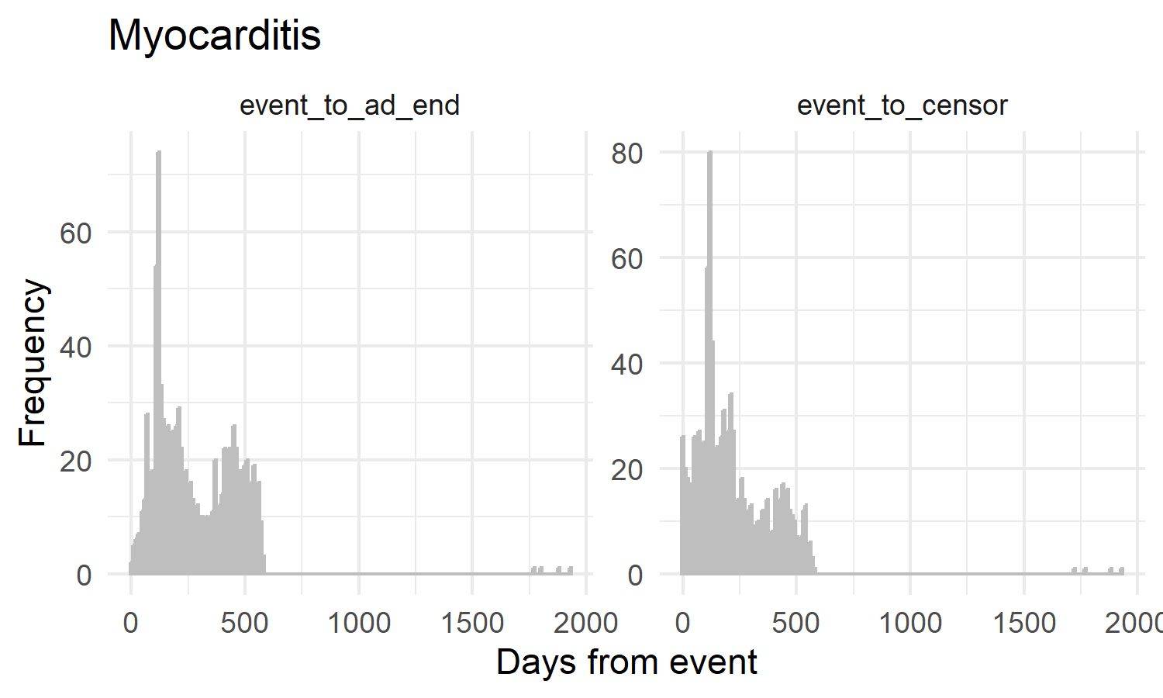

Figure 6: Distribution of time from event to end of follow-up
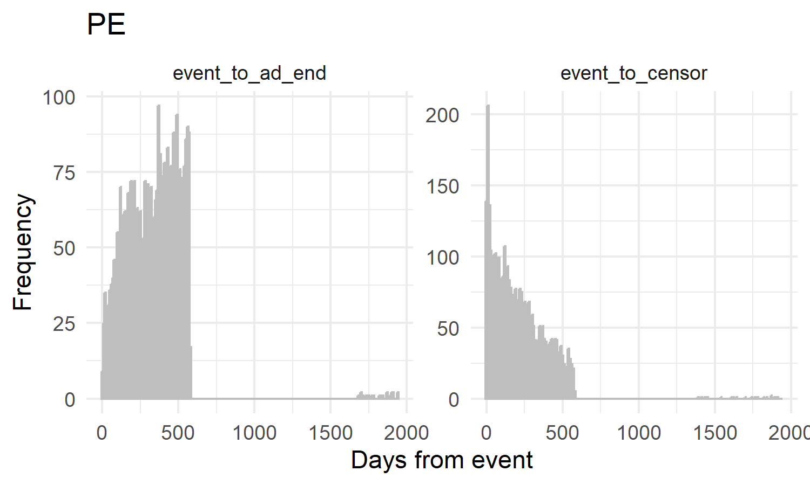
Figure 7: Distribution of time from event to end of follow-up
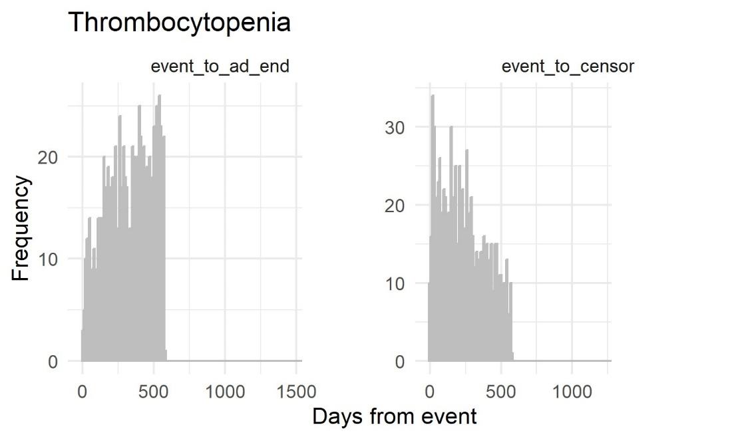
Figure 8: Distribution of time from event to end of follow-up

Event-dependent exposure
- Time interval between the start of each exposure and the event
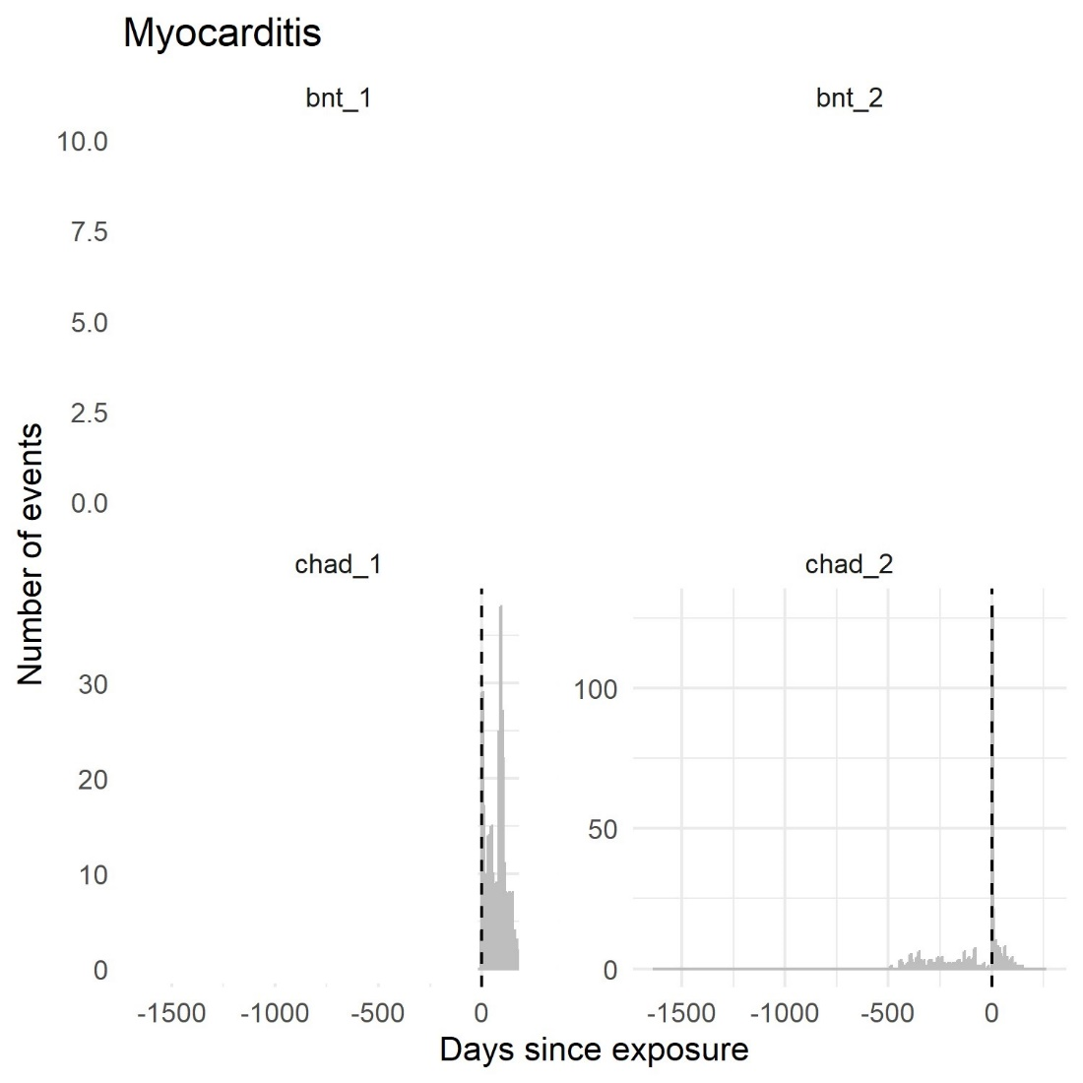
Figure 9: Number of events in exposed cases by time since exposure, for investigating event-dependent exposure
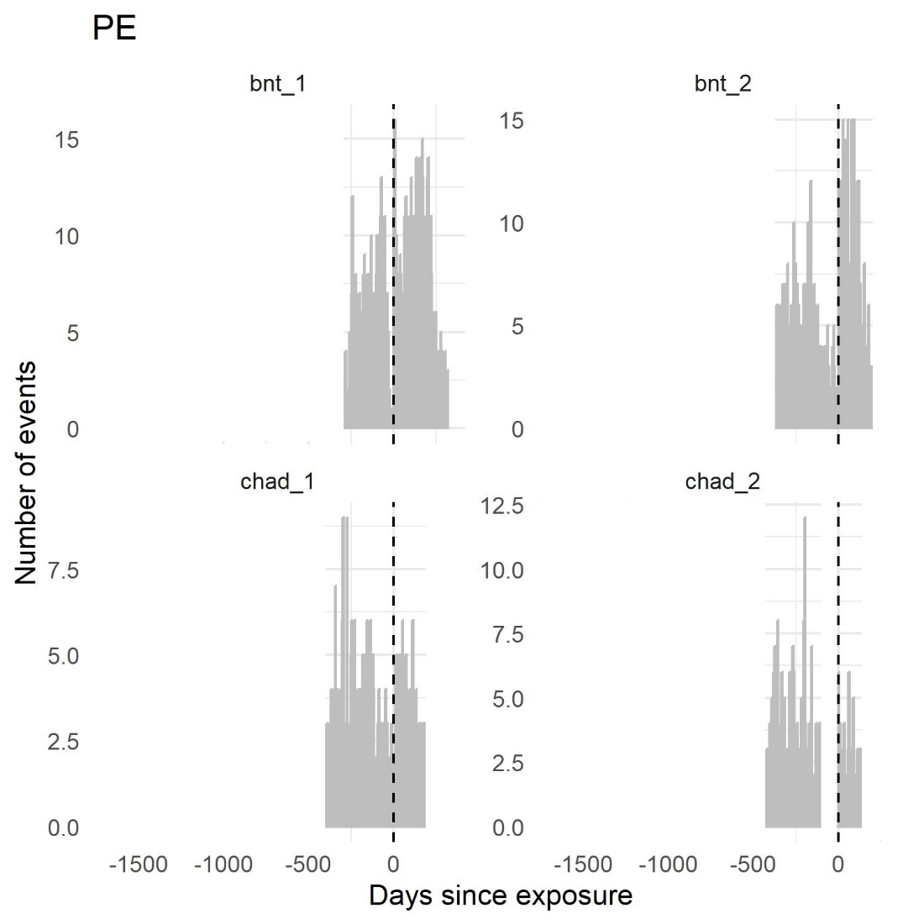
Figure 10: Number of events in exposed cases by time since exposure, for investigating event-dependent exposure
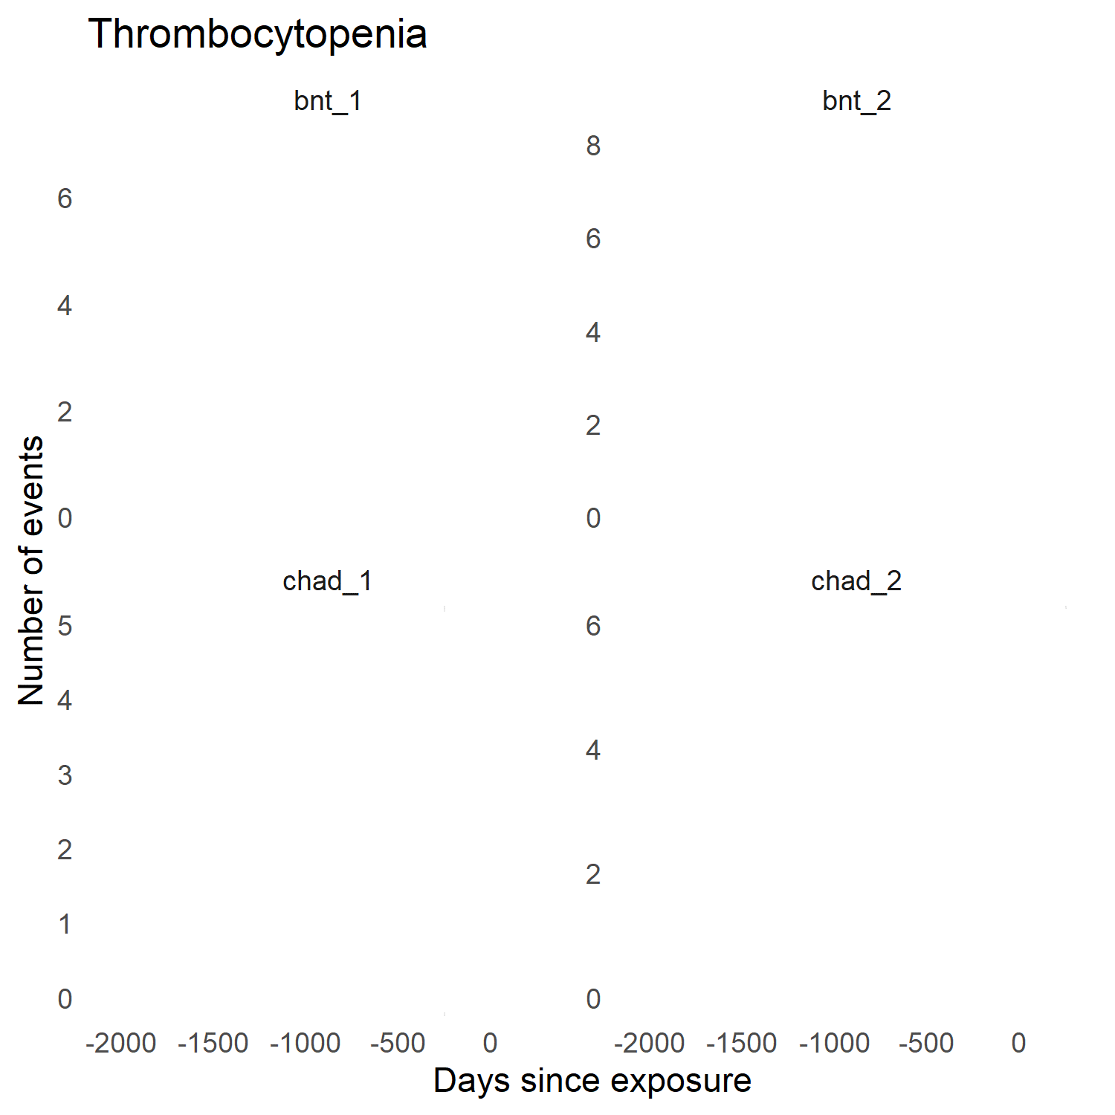
Figure 11: Number of events in exposed cases by time since exposure, for investigating event-dependent exposure
- Centred observation plots to help interpret the centred event plot
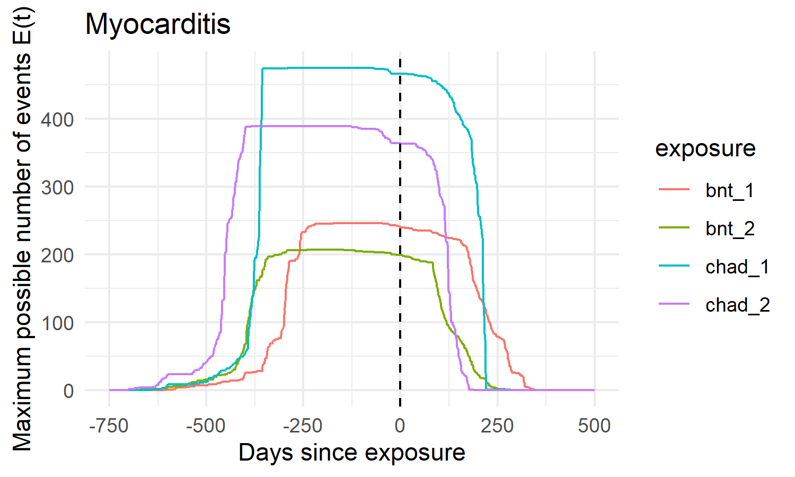
Figure 12: Centred observation plots: number of exposed cases under observation by time since exposure
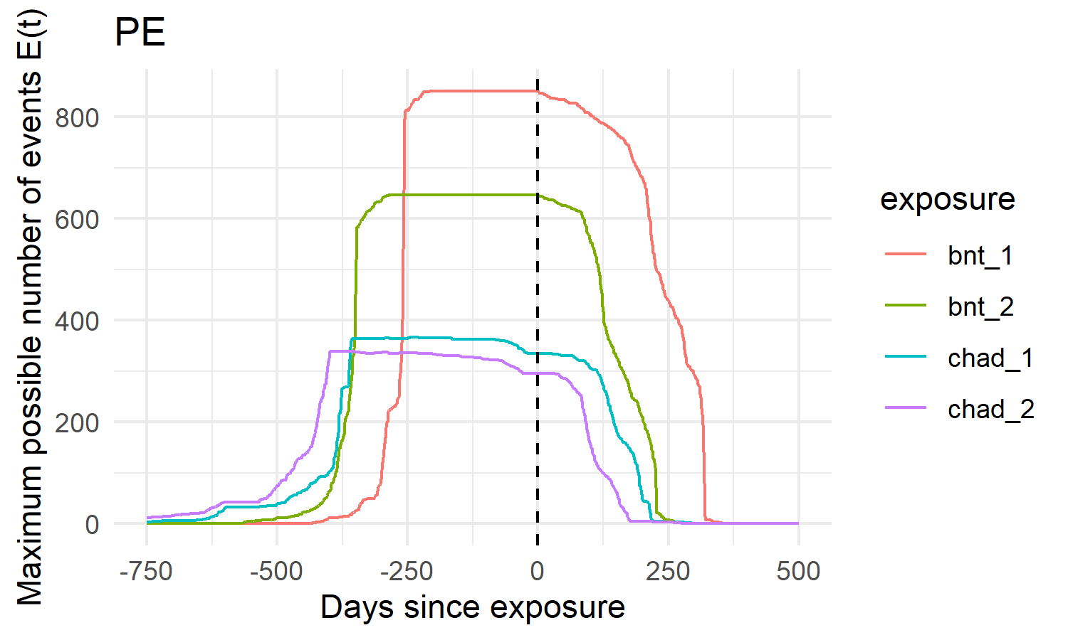
Figure 13: Centred observation plots: number of exposed cases under observation by time since exposure
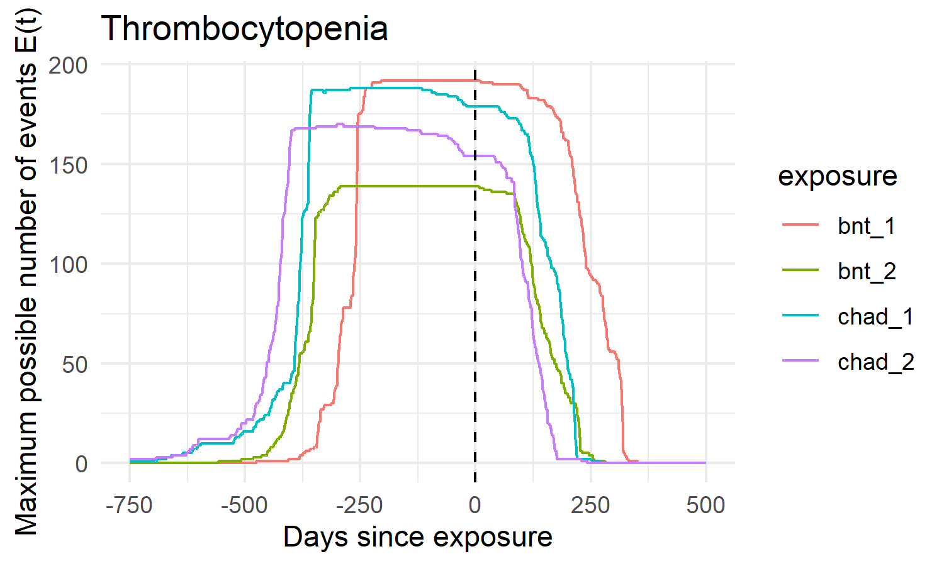
Figure 14: Centred observation plots: number of exposed cases under observation by time since exposure
The centred observation plot reflects design constraints: number of exposed cases that are under observation at a given time point (the hypothetical distribution of event relative to exposure if there is no event-dependent exposure).

Baseline characteristics of cases (per outcome)
Warning: Use of .data in tidyselect expressions was deprecated in tidyselect 1.2.0.
ℹ Please use `all_of(var)` (or `any_of(var)`) instead of `.data[[var]]`
Characteristic | Myocarditis (N = 1035) | Pulmonary embolism (N = 3666) | Thrombocytopenia (N = 941)
Age, median (IQR) | 29 (16–46) | 69 (56–81) | 58 (41–75)
Age, missing n (%) | 0 (0.0%) | 0 (0.0%) | 0 (0.0%)
Male, n (%) | 669 (64.6%) | 1670 (45.6%) | 368 (39.1%)
Sex, missing n (%) | 0 (0.0%) | 0 (0.0%) | 0 (0.0%)
Lung disease, n (%) | 76 (7.3%) | 594 (16.2%) | 100 (10.6%)
Lung disease, missing n (%) | 0 (0.0%) | 0 (0.0%) | 0 (0.0%)
Chronic kidney disease, n (%) | 53 (5.1%) | 559 (15.2%) | 119 (12.6%)
Chronic kidney disease, missing n (%) | 0 (0.0%) | 0 (0.0%) | 0 (0.0%)
Diabetes, n (%) | 67 (6.5%) | 912 (24.9%) | 188 (20.0%)
Diabetes, missing n (%) | 0 (0.0%) | 0 (0.0%) | 0 (0.0%)
Cardiovascular disease, n (%) | 79 (7.6%) | 1080 (29.5%) | 160 (17.0%)
Cardiovascular disease, missing n (%) | 0 (0.0%) | 0 (0.0%) | 0 (0.0%)
Cancer, n (%) | 25 (2.4%) | 379 (10.3%) | 49 (5.2%)
Cancer, missing n (%) | 0 (0.0%) | 0 (0.0%) | 0 (0.0%)

